**Airport database management system**

**Procedures:**

**book(cid int,fid int), cancel(cid int,fid int), show_emp(fid int)**

**Triggers:**

**update_seats, update_seats_cancel**

**ER Diagram**

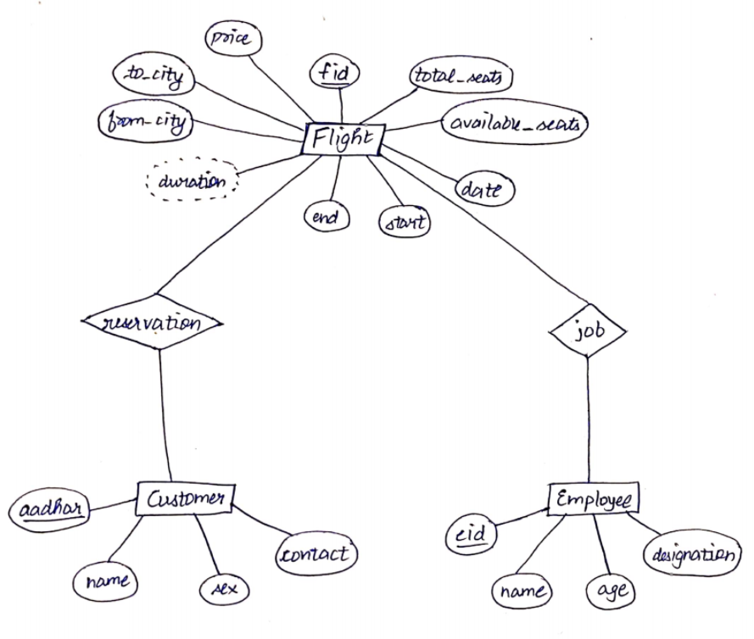

**Create and insert queries 🡪**

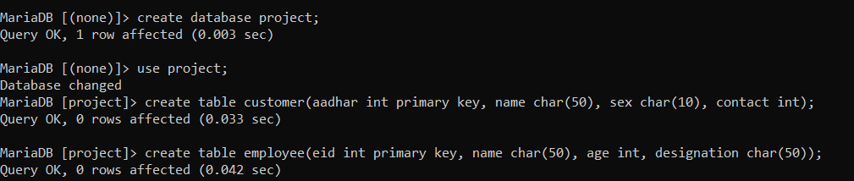

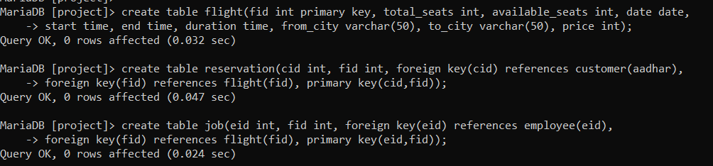

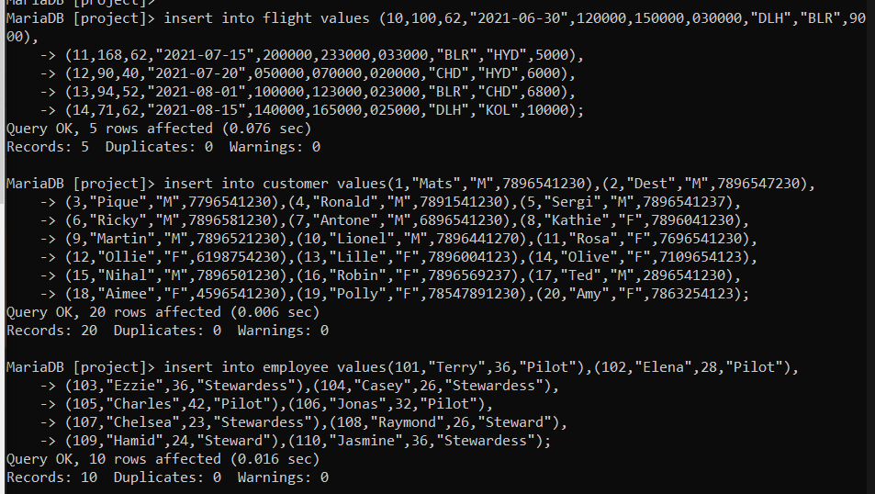

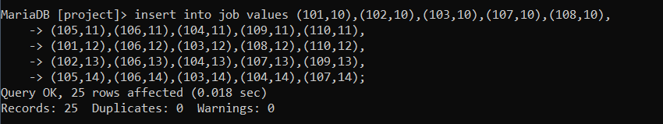

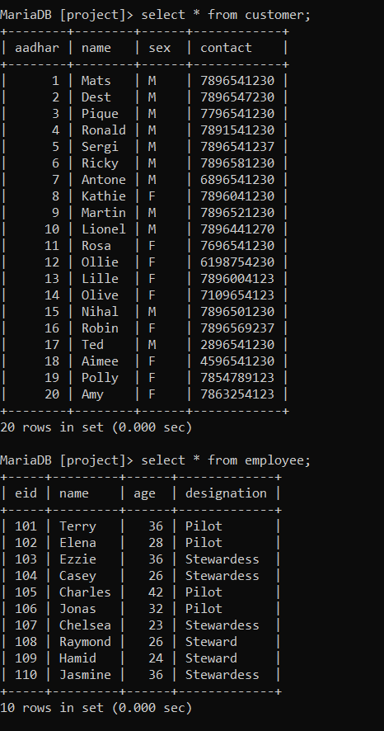

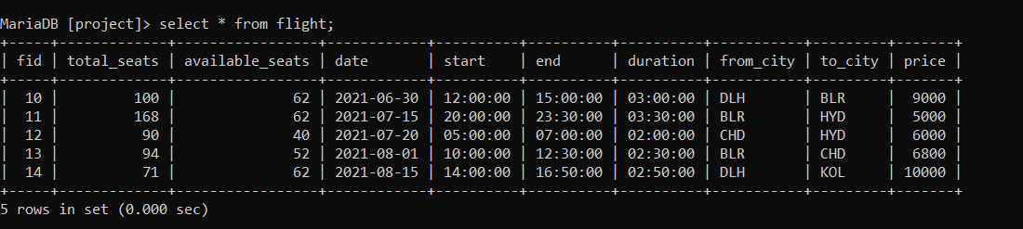

**1. Create a trigger to update available seats when a reservation is made.**

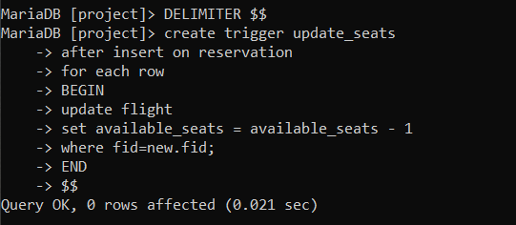

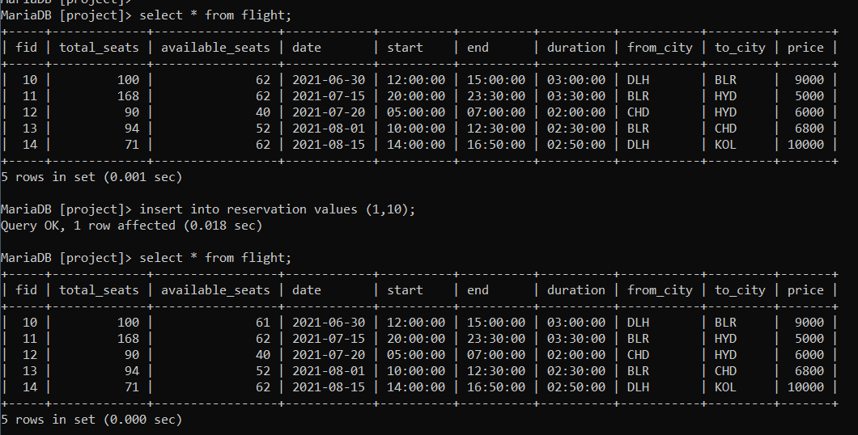

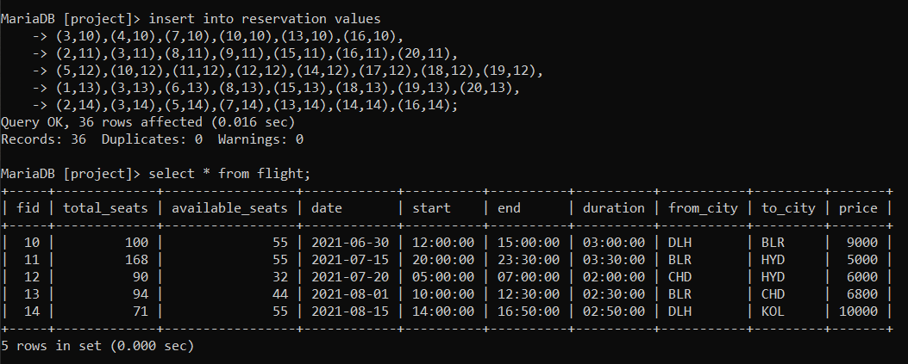

**2. Show id of customer that has reserved maximum number of flights.**

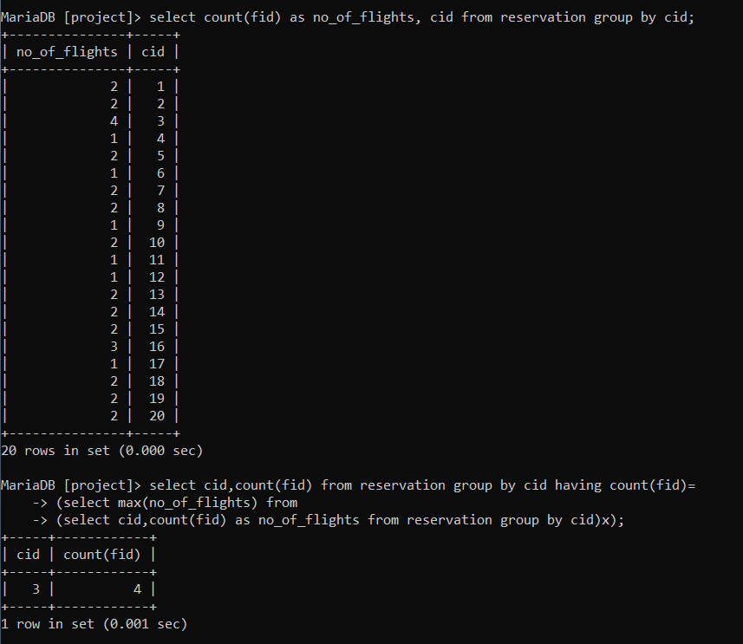

**3. Show flights that are available today and after today.**

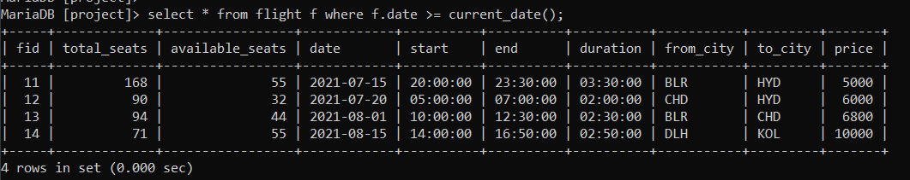

**4. Create a procedure to show all employees working on a particular flight.**

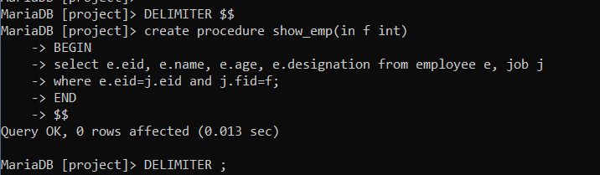

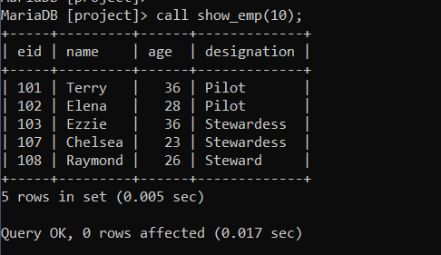

**5. Show details of flight with highest price.**

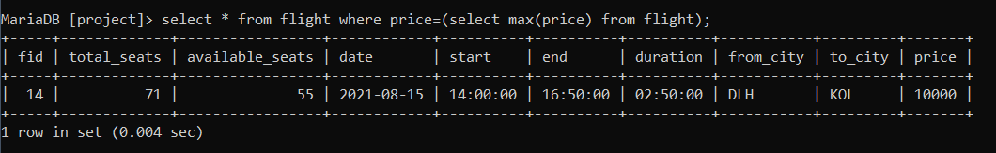

**6. Create a procedure to book a flight.**

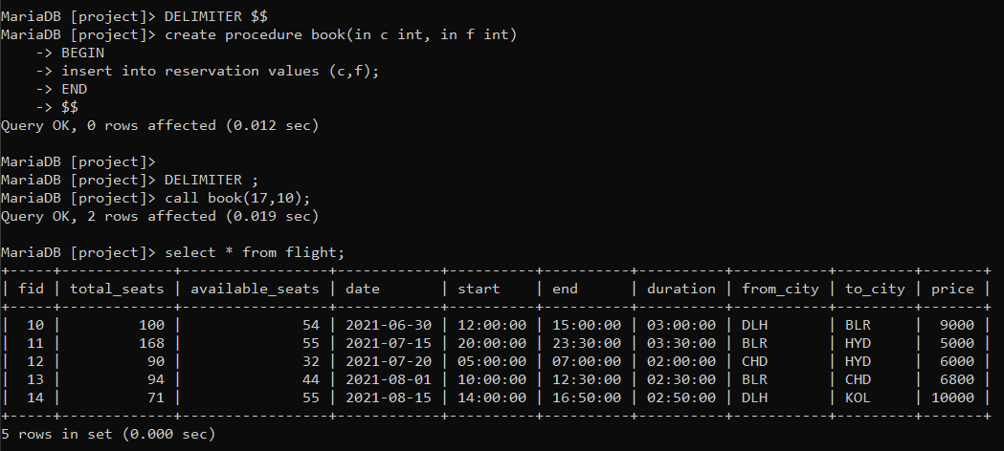

**7.** **Create a trigger to update available seats when a reservation is cancelled.**

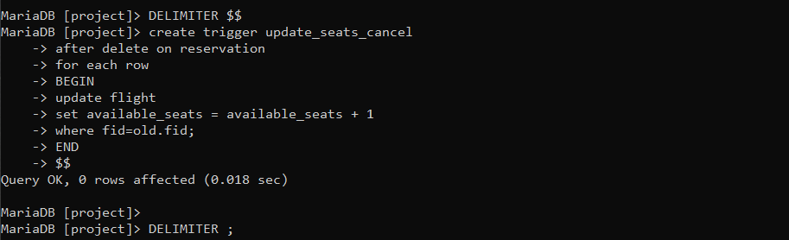

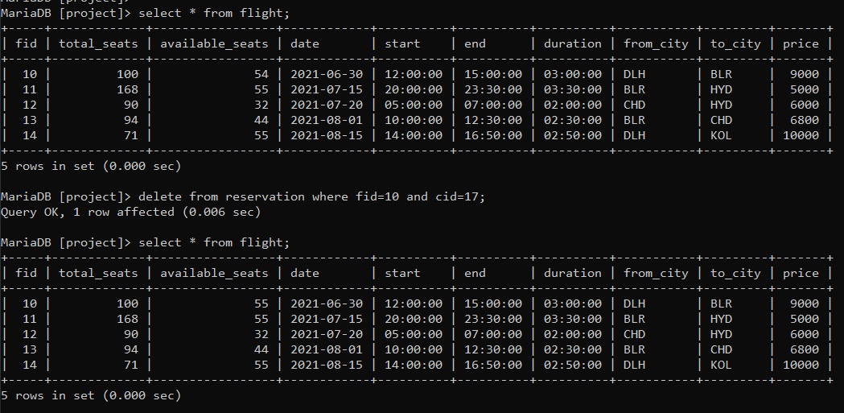

**8. Create a procedure to cancel a flight.**

